CHAPTER: 4
FRONT END OF SYSTEM

4.1 About Front End
4.1.1 about HTML
4.1.2 about CSS
4.1.3 about JavaScript

4.1 About Front End
- Front end development refers to the part of web development that focuses on creating the user interface and experience of a website or web application.
- It involves implementing designs provided by UI/UX designers using languages such as HTML, CSS, and JavaScript.
4.1.1 about HTML
- HTML stands for Hyper Text Markup Language.
- HTML describes the structure of a Web page.
- HTML consists of a series of elements.
- HTML elements tell the browser how to display the content
- HTML elements label pieces of content such as "this is a heading", "this is a paragraph", "this is a link", etc.
- HTML Page Structure
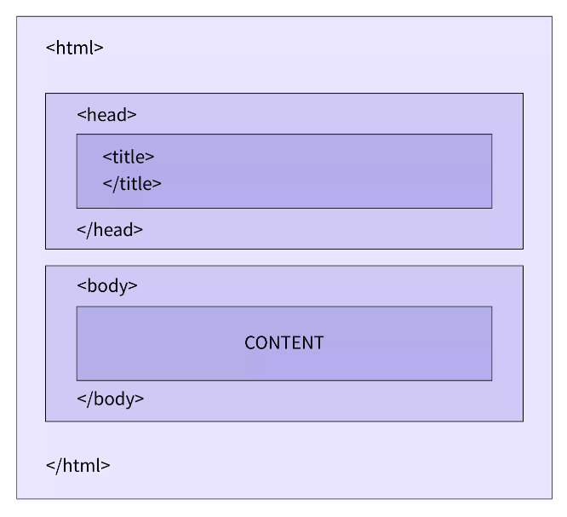
- Any HTML document mainly comprises two parts, the head and the body.
- The Head includes the additional information of the document, apart from the one displayed on the web page.
- It includes the HTML version, the title, and also the metadata.
- And the information that will be displayed on the web page is put inside the Body tag.
- HTML, or Hypertext Markup Language, is the standard language used to create and design web pages.
- It provides the structure and content of a webpage by using a system of markup tags and attributes.

